R. Reports Menu: M. State Unemployment Report

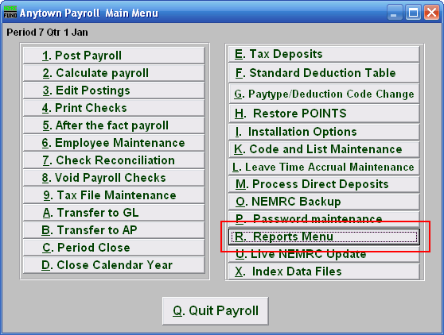
Click on “R. Reports Menu” off the Main Menu and the following window will appear:

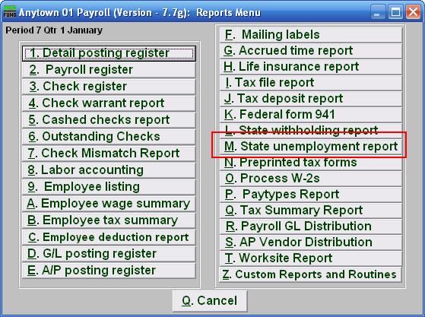
Click on “M. State unemployment report” on the Reports Menu and the following window will appear:
State Unemployment Report

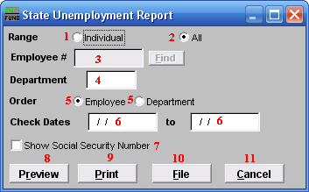
- Range: Individual: Click “Individual” if you want this report to be for an Individual Employee.

- Range: All: Click “All” if you want this report to be for All Employees.

- Employee #: This option is only available if you chose “Individual” for range. Select the Employee number for the employee that this report is for.

- Department: This option is only available if you chose “All” for range. Select the Department that you want this report to be for.

- Order: This option is only available if you chose “All” for range. Click the option for the order that you want this report to be in: “Employee” to list by Employee; “Department” to list by Department.

- Check Dates: Enter the beginning and ending date range for the checks to report.

- Show Social Security Number: Sometimes when submitting this report to the state the social security number must appear.

- Preview: Click this button to preview this report. Refer to GENERAL PREVIEW for more information.

- Print: Click this button to print this report. Refer to GENERAL PRINTING for more information.

- File: Click this button to save this report on this computer. Refer to GENERAL FILE for more information.

- Cancel: Click “Cancel” to cancel and return to the previous menu.

